Project Planning Phase
Project Planning Template (Product Backlog, Sprint Planning, Stories, Story points)

Date | 15 February 2026
Team ID | LTVIP2026TMIDS66228
Project Name | Advancing nutrition science through geminiai
Maximum Marks | 5 Marks

Product Backlog, Sprint Schedule, and Estimation (4 Marks)
Use the below template to create product backlog and sprint schedule

Sprint | Functional Requirement (Epic) | User Story Number | User Story / Task | Story Points | Priority | Team Members
Sprint-1 | Application Setup | USN-1 | Configure Streamlit page layout and dark  theme | 2 | High | Team
Sprint-1 | Meal Planning | USN-2 | Implement user input fields (restrictions,  calorie goal, activity) | 3 | High | Team
Sprint-1 | Meal Planning | USN-3 | Generate 7-day personalized meal plan display | 5 | High | Team
Sprint-2 | Nutritional Insights | USN-4 | Implement food input & nutritional dataframe  display | 3 | High | Team
Sprint-2 | Nutritional Insights | USN-5 | Create macronutrient bar chart visualization | 3 | Medium | Team
Sprint-2 | Virtual Coaching | USN-6 | Develop chat interface with session state | 3 | High | Team
Sprint-2 | Virtual Coaching | USN-7 | Add motivation tracker & progress progress bar | 2 | Medium | Team

Project Tracker, Velocity & Burndown Chart: (4 Marks)

Sprint | Total Story Points | Duration | Sprint Start Date | Sprint End Date (Planned) | Story Points Completed (as on Planned End Date) | Sprint Release Date (Actual)
Sprint-1 | 10 | 7 Days | 01 Jan 2026 | 07 Jan 2026 | 10 | 07 Jan 2026
Sprint-2 | 12 | 7 Days | 08 Jan 2026 | 14 Jan 2026 | 12 | 14 Jan 2026
Sprint-3 | 20 | 6 Days | 07 Feb 2026 | 12 Feb 2026 | 10 | 12 Feb 2026
Sprint-4 | 20 | 6 Days | 14 Feb 2026 | 19 Feb 2026 | 12 | 19 Feb 2026

Velocity:
In this project, Sprint-1 completed 10 story points and Sprint-2 completed 12 story points. Total story points = 22. Number of sprints = 2. Average Velocity = 22 / 2 = 11 Story Points per Sprint.
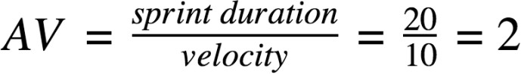

Burndown Chart:

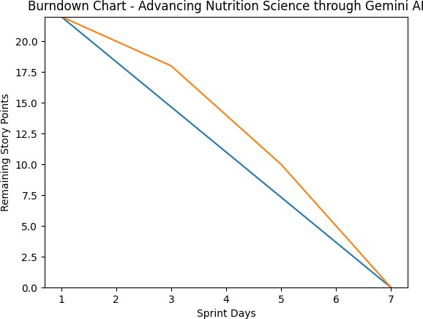

Reference:

https://www.atlassian.com/agile/project-management https://www.atlassian.com/agile/tutorials/how-to-do-scrum-with-jira-software https://www.atlassian.com/agile/tutorials/epics https://www.atlassian.com/agile/tutorials/sprints https://www.atlassian.com/agile/project-management/estimation https://www.atlassian.com/agile/tutorials/burndown-charts

